1. What is CORS?
Answer:
CORS (Cross-Origin Resource Sharing) is a security feature that allows or restricts a web application from accessing resources on another domain, port, or protocol. It enables secure communication between different origins.

2. How to Enable CORS in ASP.NET Core?
Answer:
CORS can be enabled by:
- Registering CORS services using AddCors().
- Creating a CORS policy.
- Applying the policy using UseCors() in Program.cs.

3. What is JWT (JSON Web Token)?
Answer:
JWT (JSON Web Token) is a compact, secure token used for authentication and authorization. After successful login, the server generates a JWT and the client sends it with each request in the Authorization header using the Bearer scheme.

4. What is Bearer Authentication?
Answer:
Bearer Authentication is an authentication method where the client sends the JWT in the request header as:
Authorization: Bearer <JWT_Token>
The server validates the token before allowing access to protected resources.

5. What is the Authorize Attribute?
Answer:
The [Authorize] attribute protects controllers or action methods by allowing access only to authenticated users. If the request does not contain a valid JWT token, the API returns 401 Unauthorized.
Example:
[Authorize]

6. What is AllowAnonymous?
Answer:
The [AllowAnonymous] attribute allows users to access a controller or action without authentication. It is commonly applied to the login or token-generation endpoint.
Example:
[AllowAnonymous]

7. What are Claims in JWT?
Answer:
Claims are pieces of information stored inside a JWT. They describe the authenticated user, such as User ID, Role, Name, or Email.
Example:
new Claim(ClaimTypes.Role, "Admin")
new Claim("UserId", "101")

8. What is Role-Based Authorization?
Answer:
Role-Based Authorization restricts access based on user roles. Only users with the specified roles can access the protected API.
Example:
[Authorize(Roles = "Admin")]
or
[Authorize(Roles = "Admin,POC")]

9. Why is JWT Expiration Used?
Answer:
JWT expiration limits how long a token remains valid. Once the expiration time is reached, the token becomes invalid, improving application security.

PROGRAM.CS
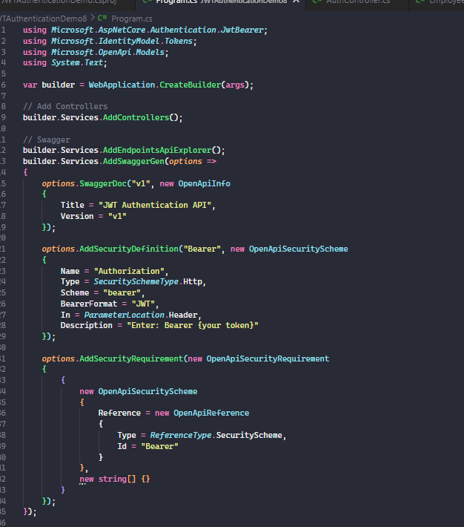
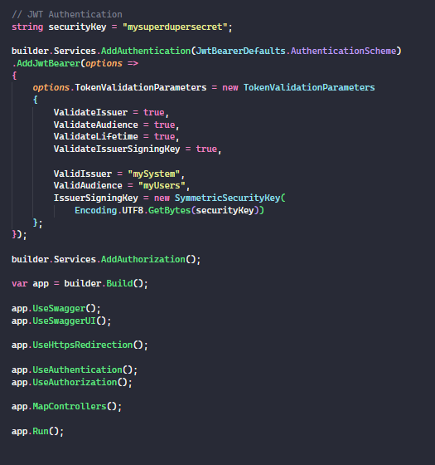
EmployeeController.cs
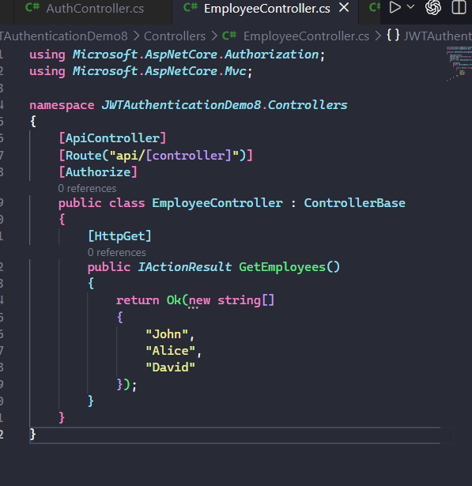

AuthController.cs
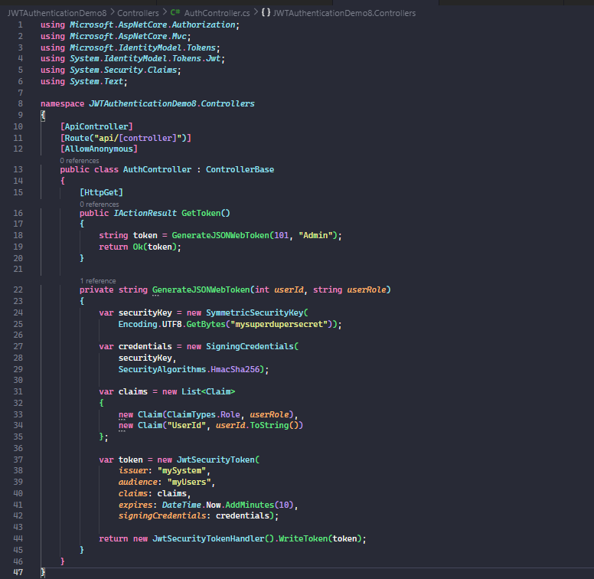

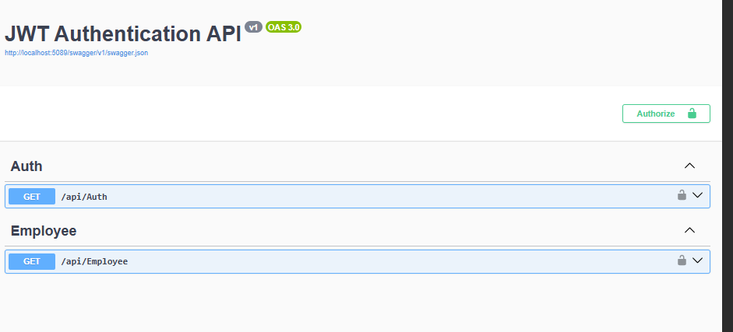
Test 1: Generate JWT Token (200 OK)
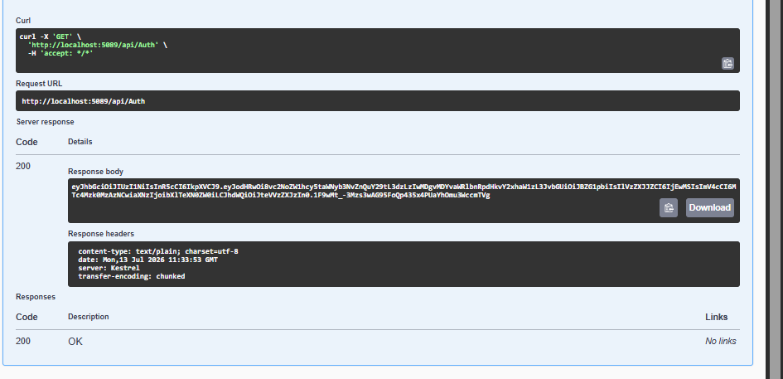

Test 2: Employee without token → 401 Unauthorized
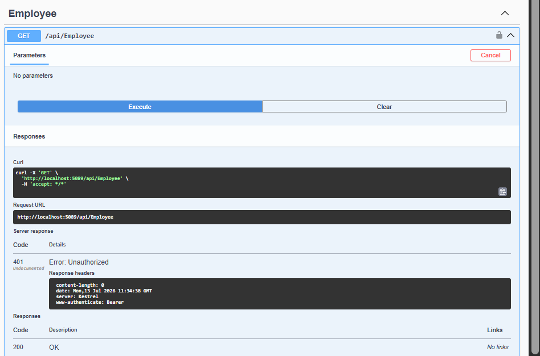
Test 3: Employee API accessed successfully using a valid JWT token (200 OK)
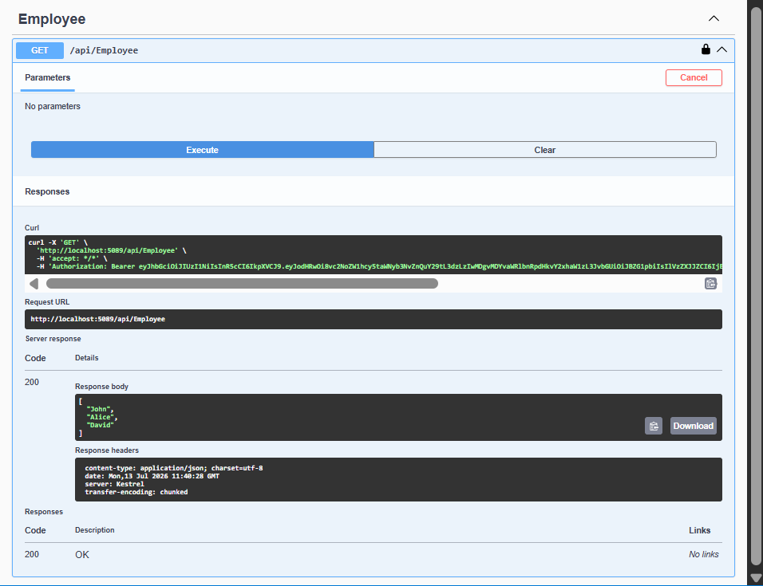

Test 4: JWT Token Expiration
AUTHCONTROLLER.CS
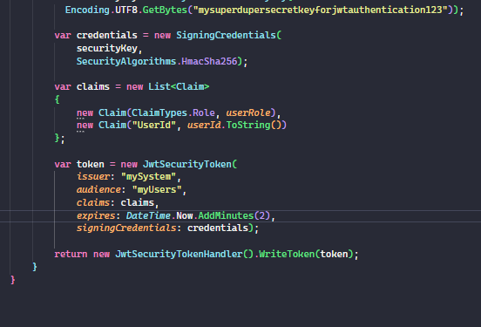
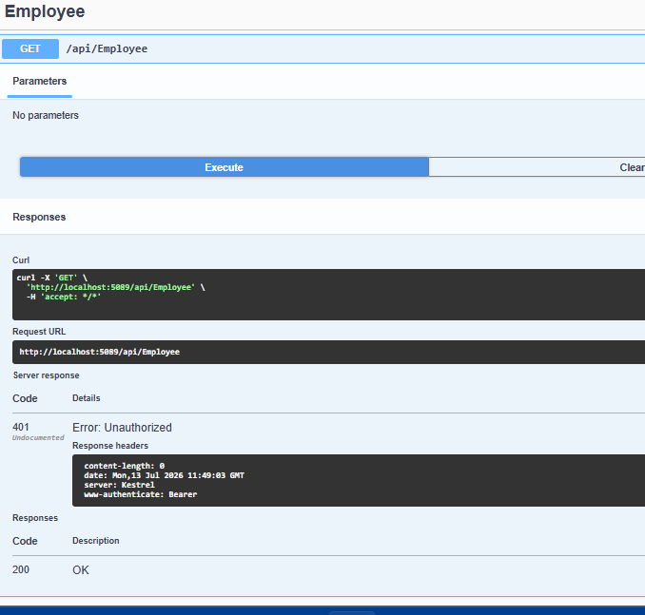
Test 5: Role-Based Authorization
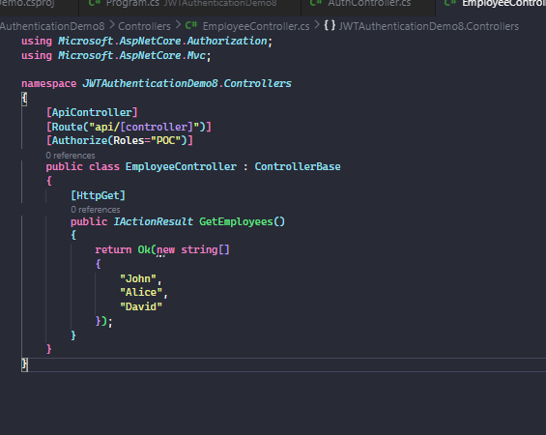
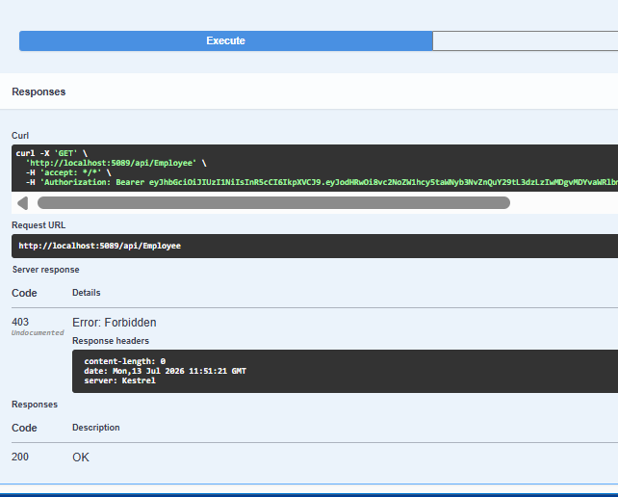
Test 6: Allow Both Admin and POC

